Contents/ Inhoud

DEAR MUSEUM FRIENDS… 2
AANKONDIGINGS 3
ISIVIVANE – WHAT THE HEAP OF STONES MEANS 4
DAAR’S ‘N VOORTREKKER OP ONS STOEP 6
VERBASENDE STORIE UIT DIE ARGIEWE 8
POND’S IS POND’S AND LION’S IS LION’S 9
GRAAFFRIKAANS 11
WORDS TO PONDER… 12

REDAKSIE / EDITORIAL STAFF

Artikels / Articles:
Anziske Kayster, hERMI bAARTMAN & wENDY VAN SCHALKWYK
Redigering / Editing:
Elizabeth Buisman & Hermi Baartman
Drukwerk en Produksie / Printing & Production:
Denise van Wyk & NOMAKHOSAZANA JACOBS
Verspreiding/ Distribution:
James van Rhyners & Zenevin Isaks

Dear Museum Friends,
They say that change is the process of becoming different. But, and you may agree, this is such a narrow-minded explanation of a small word that contains such a wealth of meaning. And as I sat in my office adopting the sober meditative pose of Rodin’s Thinker, contemplating the philosophies of change, the only words that came to mind were the words of the Bobby Mcferrin song:
Here is a little song I wrote,
You might want to sing it
note for note
Don't worry, be happy
In every life we have some trouble
When you worry you make it double
Don't worry, be happy......
And more……
Cause when you worry your face
will frown
And that will bring everybody down
So don't worry, be happy…….

As much as I hate things to become different, for circumstances to alter or adjust, to substitute one for another or to force the current into another direction, I have come to realise that change is part of living: we carry on living, despite having to say goodbye to an outstanding chairman and great colleagues or when the money to pay the bills runs out.

We also carry on living because deep down in our hearts we know that change can be for the better. Change is not so scary when you see how your colleague’s premature baby, the one who was almost born in your car seat, thrives and outgrows his shoebox. Change becomes acceptable when the new chairman of the board is an exceptional woman with infectious enthusiasm, an enormous heart and big plans for the future. Change is embraced when you see how your colleagues work together as a team in the face of severe staff shortages and how they grow to become great individuals.

Ultimately, dear friends, I have come to realize that change is just a small coin to be stuffed into your pocket and used to pay the parking attendant.

AANKONDIGINGS

Die nuwe voorsitter van die Trusteeraad is ‘n baie bekende in Graaff-Reinet Museum kringe. Hermi Baartman is in Julie 1994 as kurator van die Museum aangestel en was deel van die museumfamilie tot en met haar aftrede in 2009. Sy was onmisbaar en moes na haar aftrede noodgewonge haar plek weer langs ons raadstafel inneem toe sy as Vriende van die Museum verteenwoordiger verkies is. Na Mark Fynney se uittrede as voorsitter, ‘n posisie wat hy vir meer as sewe jaar beklee het, het die huidige trusteeraad eenparig besluit dat sy die aangewese persoon sou wees om die leisels oor te neem. Haar ervaring en lewenskennis is al reeds ‘n groot aanwins en ons voorsien dat hierdie museum onder haar bekwame voorsitterskap sal bloei.

Terselfdertyd is Peter Whitlock as onder-voorsitter van die raad verkies. Die trusteeraad is in die bevoorregte posisie om sy kennis, ervaring en liefde vir die saak tot hul beskikking te hê. Graag nooi ons al die Vriende van die Museum en ander belangstellendes uit om ons Trusteeraad tydens die Jaarlikse Algemene Vergadering wat op Donderdag, 7 Junie 2012, by die Ou Biblioteek gehou sal word, te kom ontmoet.

Liz and Gerald Buisman, who will be having a gap in ‘the English countryside’ by the end of May will be sorely missed. Liz has been a board member for a very long time; in fact, she became a board member almost upon her arrival in Graaff-Reinet. For years she edited all our newsletters, minutes and reports, baked for our street stalls and donned the proverbial armour for the many challenges that came our way. Not only was she an exemplary board member, but also a good friend, lending a sympathetic ear and offering much needed advice on motherhood, husbands and, yes, losing weight. Dear Liz, the board room will not be the same.

Klein Durin Booysen het amper op Reinethuis se stoep sy eerste lewenslig aanskou. Gebore op 34 weke en baie klein, het hierdie klein soldaatjie bewys dat hy hom nie maklik onderkry nie. Ons kollega, Katriena Booysen, is a trotse mamma en Durin het duidelik bewys dat lede van die museumfamilie murg in hulle pype het. Baie welkom, groot man en baie geluk, mamma.

We are all geared up for the Murray reunion, which will take place from 28 June to 1 July. All Murray descendants are urged to contact Sholto Kroon, chairman of the local organizing committee, at sholto@yebo.co.za. It promises to be an exciting event.

ISIVIVANE –
what the heap of stones means
BY WENDY VAN SCHALKWYK

In November 1777, Robert Gordon records that he left the farm Vrede, between Aberdeen and Graaff-Reinet. “We passed a heap of stones 20 foot in diameter.” In 1935 and 1994 Guy Butler visited Vrede and saw that the cairn was less than a kilometre from the homestead, partly obscured by a bush. The stones were large, coconut-sized, about 200mm in length and 100 – 200mm in width. This cairn was 400m from the base of the hills and 600m from the river.

The earliest record of an interpretation of the cairns was given by Gordon who recorded that the cairn at Vrede was the grave of a chief of the Camdeboo Hottentots called “Corana”. Apparently the chief was killed by an elephant. This opinion was also expressed by Lichtenstein in 1815. “The grave of a Bushman captain or chief….consisted of a large cairn of stones with branches of trees, and Mr Edwards informed us that each Bushman on passing the pile was in the habit of adding a stone to the heap, as a mark of respect for the deceased”. (Borchards, 1861).

The Khoi buried their dead by covering the body with stones. When they pay homage to the dead it is called heidje eibeb. In the event of the grave being close to the road, the wayfarers throw a stone on the mound when passing by. Neither the Xhosa nor the Zulu people followed this practice of covering their dead with stones, but it is interesting to note that the Xulu and Xhosa refer to the cairns as isivivane.

No one ever passed a cairn without putting on a stone. If stones were not readily available, twigs or leaves were used instead. Doing this, gave them strength for the journey ahead much like it did for the European St Christopher.

John and his son, John Allen Biggs, from Vrede said that this practice of piling stones onto a burial mound was not an unknown practice among their farm labourers. In 1935 the grave at Vrede was known as a cairn of stones; today we know that this is an indication of the cognitive way of thinking of the Khoi and their firm belief in an afterlife. A kloof near the heap of stones, known as Kaptein’s Kloof is a burial site in which this burial practice of the Khoi is also exhibited. According to legend, a Xhosa captain was killed by the Khoi and buried in the same manner as the Corana chief.

John Biggs said that his relative, Guy Butler, proposed a different explanation for the cairn. According to him the heap was created by travellers passing Vrede and who followed the game between the Karoo plains and the mountains. The traveller had to collect a stone, spit on it and place it on the heap to ensure good luck.

Today we know that Heidjie Eibeb (or Heitsi-Eibib) is a mischievous Khoisan ancestor hero, who controls the early fate of individuals. The cairn identifies a site as sacred to Heitsi-Eibib, who is sometimes compared to the likes of Puck. After adding a stone to the cairn a Khoikhoi man would cover the back of his head with his hand while walking away, so that Heitsi-Eibib’s suggestions would not enter his mind. Many graves of the ancestor hero exist in the Khoisan habitat and many believers use these sites to meditate and to add more stones as offerings of good fortune. Today, valuable personal objects are also covered with small stones to identify a holy place so that any passerby can add a stone ensuring that it becomes a constantly renewed shrine.

DAAR’S ‘N VOORTREKKER OP ONS STOEP…

Wel, nie die een of twee waaraan jy gedink het nie.

Jan Gerritze Bantjes, sekretaris van die Provinsiale Voortrekker Administrasie en die Kommandeur Generaal van die Voortrekker Andries Pretorius is op 8 Julie 1817 in Graaff-Reinet gebore. Per geleentheid het hy as Klerk van die Natalse Volksraad opgetree en was hy die opsteller van die verdrag tussen Piet Retief en Dingaan. Hierdie verdrag, wat op 4 Desember 1838 onderteken is, is deur Bantjes in sy eie handskrif opgetrek. Dit was ook Bantjes, bevelvoerder van die kommando, wat die nuus van Retief se dood aan die res van die Voortrekkers moes oordra. Hy het die Voortrekkers se kinders onderrig en selfs Paul Kruger en Marthinus Wessel Pretorius het onder sy hand deurgeloop. Bantjes was ook ‘n befaamde dagboekskrywer wat die wel en weë van die Voortrekkers deeglik aangeteken het. Hy het ‘n belangrike posisie in die binnekring van die Voortrekkers beklee en was teenwoordig toe die gelofte aan God by die Waschbankspruit op 09 Desember 1938, gemaak is

Jan Gerritze Bantjes was ‘n bruin man en is die direkte afstammeling van die plaaslik gebore Hilletjie Agnita van der Caab uit ‘n verhouding met Jan Gerrit Bantjes. Hilletjie se ouers was die slawe Jan Jacobs en Anna Pieters. Hierdie inligting word deur die Heese en Lombard geslagsregisters gestaaf.

Die feit dat Bantjes ‘n bruin man is word nie betwyfel nie veral nadat die Voortrekkers se dominee, Erasmus Smit in sy dagboek skryf: “Mnr De Klerk het ‘n jong kleurling man saam met hom gebring, en aangesien laasgenoemde sekere talente gehad het, het ek hom versoek om ‘n passasie te lees en te sing. Sy naam was Jan Bantjes.” Verder word daar na Bantjes verwys as ‘Sekretaris”, “Skrywer” of “Amanuensis, maar geen verdere verwysing na sy kleur of ras nie.

Die vraag ontstaan egter hoekom soveel vergunnings aan Bantjes gemaak is. Kon dit wees dat baie van die Voortrekkers ook van gemengde afkoms was? Daar word beweer dat Andries Pretorius dieselfde afkoms as Bantjes gedeel het. Hierdie ware verhaal het die jakkals in die hoenderhok losgelaat en het Jan Bantjes van Graaff-Reinet onmiddellike sterstatus verkry met die verskyning van Max du Preez se boek Of Tricksters, Tyrants and Turncoats- more unusual stories from South Africa’s past.

Schalk W Jacobs skryf dat die mite dat J G Bantjes van Bloedrivier ‘n “bruin” man was, is die gevolg van ‘n wanlesing van die woord “brein” in langhand geskryf in Erasmus Smit se dagboek toe hy na Bantjes verwys het as ‘n “skrander brein jong man”. Die Boere van die tyd het na die kleurlinge verwys as “basterds” en nie “bruinmense” nie.

Die historiese korrektheid van Du Preez se artikel word betwyfel en baie kommentaar word gelewer deur die afstammelinge van J G Bantjies, sy pa. J G Bantjes het twee ander vrouens gehad wat verskillende sytakke in die familie tot gevolg gehad het.

Jan Bantjes trek in 1855 terug Graaff-Reinet toe en agt jaar later word hy die landdrosklerk en posmeester van die Zuid-Afrikaansche Republiek in Pretoria. Hy sterf in 1887 aan huis van sy oudste seun in Potchefstroom. ‘n Jaar tevore het sy jongste seun ook Jan Gerritze, die eerste goudmyner aan die nuutontdekte Witwatersrand geword.

Lees gerus wat Reggie Nel (en andere) in sy blog A piece of my mind te sê het. Vir ons is dit belangrik om weer te bewys dat alle paaie na Graaff-Reinet lei.

(Reference: www.rwnel.blogspot.com)

VERBASENDE STORIE UIT DIE ARGIEWE
Deur Hermi Baartman
Die dorp se Africana –boekeversameling, in bewaring gehou deur die Graaff-Reinet Museum, bevat volumes van onskatbare waarde. Dit het my groot plesier verskaf om die boeke te hanteer. Baie spesiaal is die notule-boek van die biblioteekvereniging, geskryf in die handskrif van die bekende fotograaf, William Roe. Ek was jammer om te lees dat daar in een van die vergaderings besluit is om die ou boeke te gaan weggooi. Die versameling kon soveel groter gewees het. Die boek wat my egter baie na aan die hart lê, bevat die navorsingswerk van Prof. W.H.I. Bleek en sy skoonsuster, Lucie C. Lloyd, wat San prisoniers van die Breekwater Gevangenis, aan huis geneem het om sodoende die oer-taal van die Eerste Mense, op te teken. Hier is een van die storietjies wat my aangegryp het (Ek moes die woord leveret opsoek aangesien ek geen idee gehad het dat dit ‘n klein hasie is nie):
HOE |HANµKASS’Ö’S SE TROETEL-HASIE DOODGEMAAK IS. (SOOS VERTEL IN JULIE 1878)
Uit BUSHMAN FOLKLORE deur oorlede W.H.I. BLEEK PH.D. en L.C.LLOYD. Met inleiding deur GEORGE McCALL THEAL
“My moeder het my troetelhasie doodgemaak en ek wou hê my ma en ouma moet vir my ‘n ander hasie soek; hulle het my hasie doodgemaak. En hulle het my getroos en my vertel wat die akkedis gesê het.
Oupa was die een wat gaan jag het en die baba-hasie gevang het. Hy het dit lewendig vir my gebring.
Ek het daarmee gespeel; as ek dit neersit, het dit so gespring-spring, dan vang ek dit weer, oor en oor. My ma wou hê ek moet dit dood maak sodat sy dit kan braai, maar ek wou dit nie doodmaak nie, want vir my was daar niks mooier as wanneer die hasie so fyntjies hardloop, terwyl die oortjies so saam-saam beweeg. Dit het so oulik gehardloop en gaan sit, dan beweeg die oortjies so.

Toe stuur hulle my om water te gaan haal, want ek het altyd vinnig gaan water haal en nie eers daar rondgespeel nie. Ek het my hasie vasgemaak.

Toe ek terugkom, sien ek hulle het my hasie doodgemaak om gaar te maak. Ek het gehuil, want hulle het vir my ‘n rat voor die oë gedraai. Ek het gedink hulle sal na my hasie kyk. Ek wou graag hê die hasie moet in vrede verder lewe. Nou is dit dood, en ek was hartseer.

Hulle het my probeer troos. My ma het gesê ek moet nie met kos speel nie, want ons speel nie met kos nie. Die hasie is nie baie vet nie, daarom word dit gerooster.

London – GEORGE ALLEN & COMPANY, LTD
RUSKIN HOUSE 44 & 45 RATHBONE PLACE, W 1911

Pond’s is Pond’s and Lion’s is Lion’s
It is amazing how many household brands have stood the test of time. When doing research in the old newspapers, the old adverts always bring a smile to one’s face. One cannot comprehend how much time, effort and creativity went into designing an advert for a newspaper of 1894 and even one for newspapers of the more modern World War II era. Labels, and probably the ingredients, have changed through the years, but the well-known brand name remained. I am almost certain that the focus of the adverts has also shifted over the years as people became aware of the power of influence, customer focus, client orientation and individual needs. Let’s see how these well-known household products were advertised years ago:
Pond’s facial cream:



Nestlé Milk:
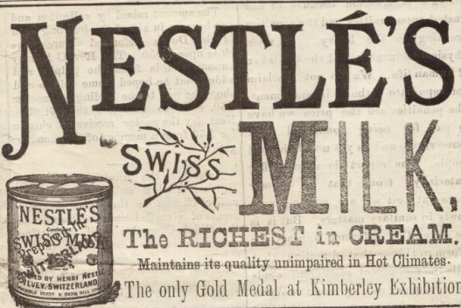
Life Buoy Soap:
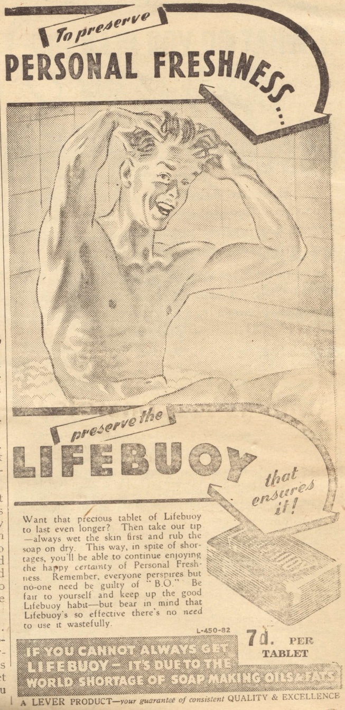

Cross & Blackwell:
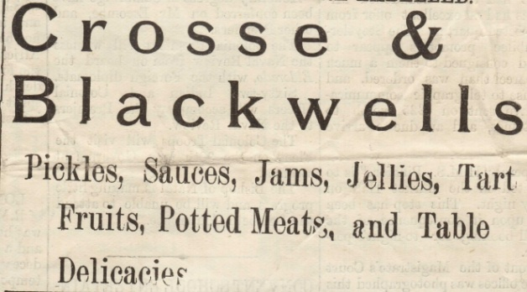

Lion Lager:


and my favourite:
Rose’s Lime Cordial:


GRAAFFRIKAANS

Visitors to our little dorp always ask me what the predominant language is, but here in Graaff-Reinet we have an efficient way of mixing our languages to give expression to emotion and sommer just because it sounds lekker.

Dr Jan van der Westhuizen wrote in The Angora Goat and Mohair Journal that the mixing of languages in this way, is considered to be absolutely normal as if that was the way it was done. No one considered it strange whether it was spoken at a casual meeting or an important director’s meeting. This mixing of languages was coined Graaffrikaans.

Nancy Kingwill writes: If you don’t speak Graaffrikaans then, foeitog, you don’t know South African English. Here, in our platteland dorp, we’ve got to hou kop when an uitlander comes to kuier or he’ll get half deurmekaar with our skeef English. And don’t los out the Rooineks who went to Bishops and St. Andrews, hey! They are eintlik worse than the ous from Volkskool who try to talk ordentlike English.
Toemaar, we’re a helpmekaar klomp on the whole, from those who spog at the Stockfair with their spekvet hamels that were reared on the vleis to get them slagbaar in the droogte. You won’t verneuk the auctioneer with your vrekmaer stock that you ja’d out the mountain after the first little vlagie, to spare the vlakteveld.
You maar groet everyone on Stockfair days, even those you know so padlangs, and the dikbek outjies who are shortoff with you. Shame, perhaps they are vies because the last time they called in at your place, your wife gave them a kaal tea. A ‘kaal tea’ refers to tea without eats.
Nee wat, if you really want to hear ware South African, you should come and hear how we talk, because it’s mos verspot to expect me to say ‘family-fond’ like Jane Austen in Bath when I erfed the word ‘familievas’ from my ouma on Klipfontein. Platweg we may be, but dom we are not.
You people can gerus consult us if you want pure South African English — it’s our taal, it’s mooi, and we can’t kom klaar without it.

Tony (as quoted in The Angora & Mohair Journal) says: It was really hot that day when I attended the begrafnis of old Swanepoel. The Swanepoels were bywoners on our farm for many years so I felt it was my plig to represent the family. The kis was put in the shade of the pruimboom, which apart from the odd karoobossie and the people attending the begrafnis, was the only other thing that represented life on the werf. Now old Ds Swanepoel was maar a bit langdradig and when it came to the gebed, he behoorlik tested our geduld. It was at this time that I noticed a Swiesbok loer-ing around the corner of the bywonershuis and I immediately noticed that the bok was korrel-ing for the only bit of green on the werf. So by the time old Ds Swanepoel said ‘Amen’, the Swiesbok had already verdwyn-ed around the corner with the krans in its mouth.

WORDS TO PONDER….

There once were two cats of Kilkenny
Each thought there was one cat too many
So they fought and they fit
And they scratched and they bit
'Til (excepting their nails
And the tips of their tails)
Instead of two cats there weren't any!

